|  |  |
| --- | --- |
| **Report Title** | Holdover­Baseline Test­CLS |
| **Report Description** |  |
| **Company** | SHIWA NETWORK |
| **User Name** |  |
| **Network Operator** |  |
| **Test Location** |  |
| **Report Date** | 2025­07­21 18:30:57 |
| **Beginning of Test** | 2025­03­17 03:50:07 (local instrument time) |
| **End of Test** | 2025­03­18 03:49:27 (local instrument time) |
| **Test Duration** | 00:23:59:20 |
| **Instrument Type** | Sentinel |
| **Instrument Serial Number** | 400188 |
| **Software Version** | 2.14.0.0.6417­20220728 |
| **CAT Version** | 27.0.21154.2116 [S] |
| **Notes** |  |

**Mask results:**

|  |  |
| --- | --- |
| **All Mask Results** | Pass |

|  |  |
| --- | --- |
| **Mask C Time Error Result** | Pass |

Instrument Test Configuration

|  |  |  |
| --- | --- | --- |
| **Frequency Reference**  **Source** |  | Internal ­ Rb |

Channel C Test Configuration

|  |  |
| --- | --- |
| **Network / Device Under Test** |  |
| **1pps TE Relative Sample Rate** | 1 |
| **Cable Delay Compensation** | 0 s |
| **PPS Converter Used** | No |

1pps TE Relative Measurement

|  |  |
| --- | --- |
| **Channel** | C |
| **Description** |  |
| **Measurement Start** | 2025­03­17 03:50:07 (local instrument time) |
| **Measurement Stop** | 2025­03­18 03:49:27 (local instrument time) |
| **Mask Time Error** | 1 µs |
| **Mask Result** | Pass |
| **Mask Time Error (Filtered)** | 0.005 µs |
| **Mask Result** | NoMask |
| **Mask Avg Time Error (cTE)** | 0.05 µs |
| **Mask Result** | NoMask |
| **Mask Dynamic TE LF** | 1.1 µs |
| **Mask Result** | NoMask |
| **Mask Dynamic TE HF** | 0.2 µs |
| **Mask Result** | NoMask |

|  |  |
| --- | --- |
| **Offset Removal Applied** | Off |
| **Zero Offset** | ­0.0024 ppb |

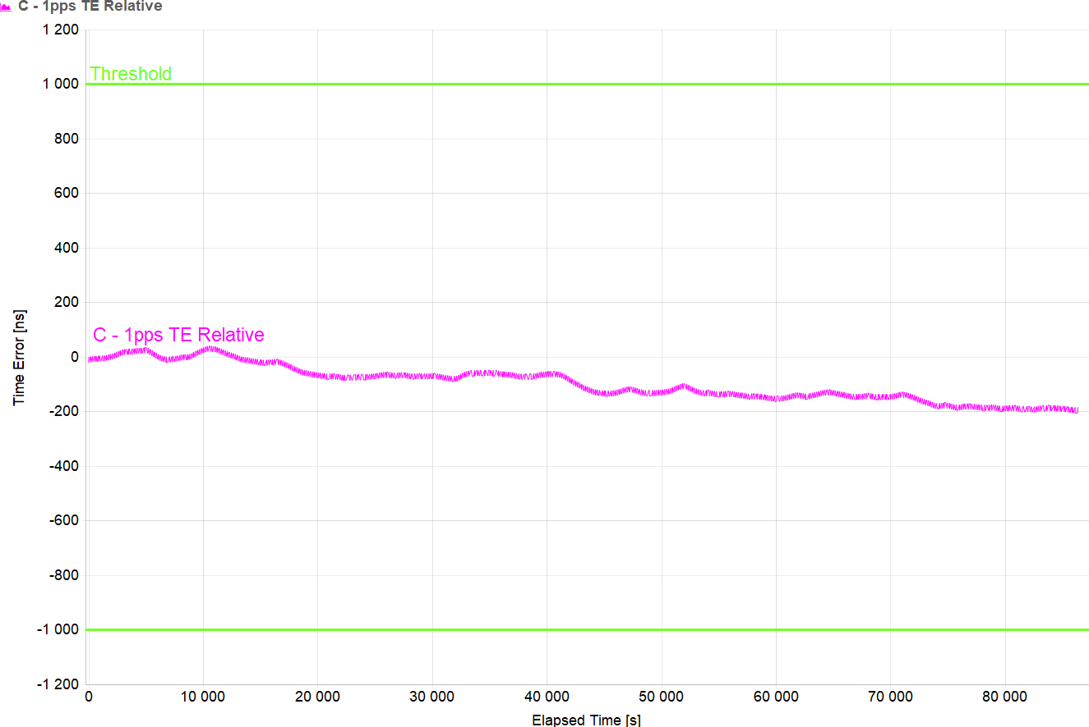

|  |  |
| --- | --- |
| **Mean** | ­100.841 ns |
| **Min** | ­205.7 ns |
| **Max** | 40.7 ns |
| **Max-Min** | 246.4 ns |

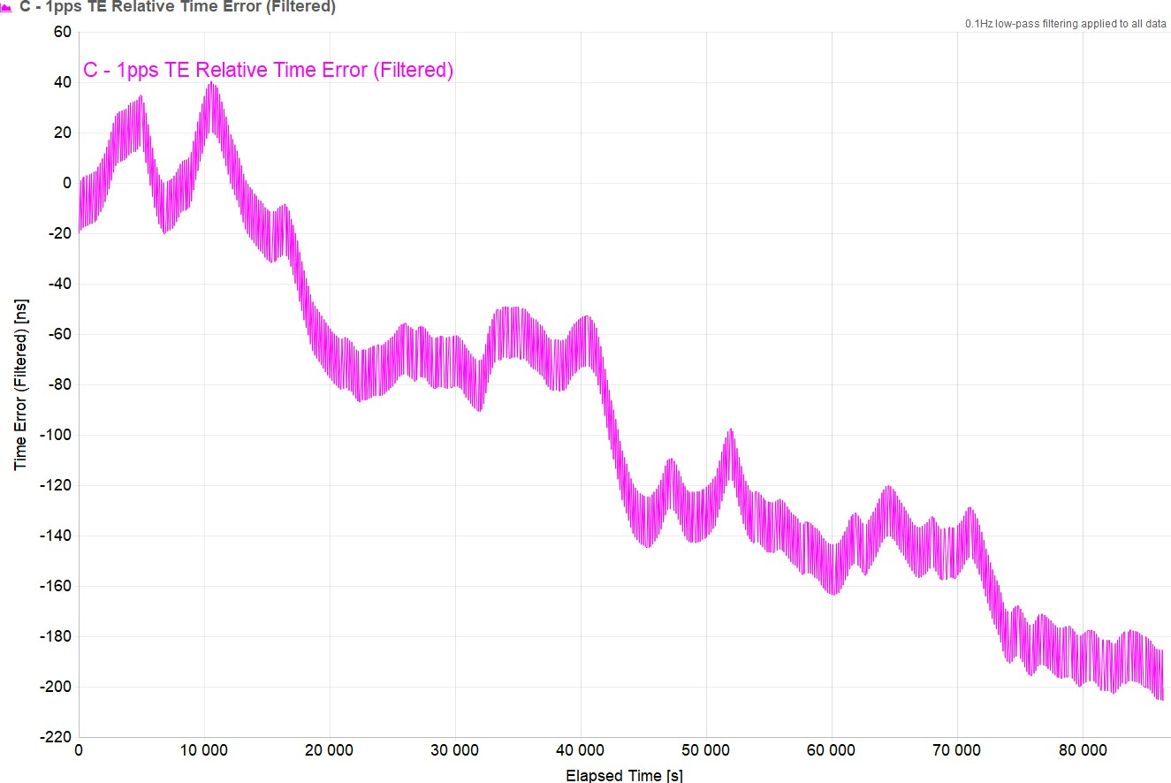

|  |  |
| --- | --- |
| **Mean** | ­100.854 ns |
| **Min** | ­205.545 ns |
| **Max** | 40.328 ns |
| **Max-Min** | 245.873 ns |

|  |  |
| --- | --- |
| **Averaging Period** | 1000 s |

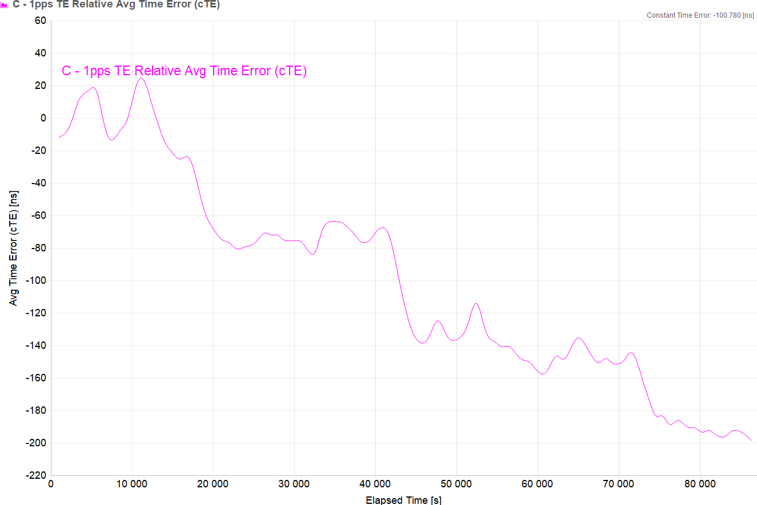

|  |  |
| --- | --- |
| **Constant Time Error** | ­100.78 ns |
| **Min** | ­198.784 ns |
| **Max** | 24.737 ns |
| **Max-Min** | 223.521 ns |

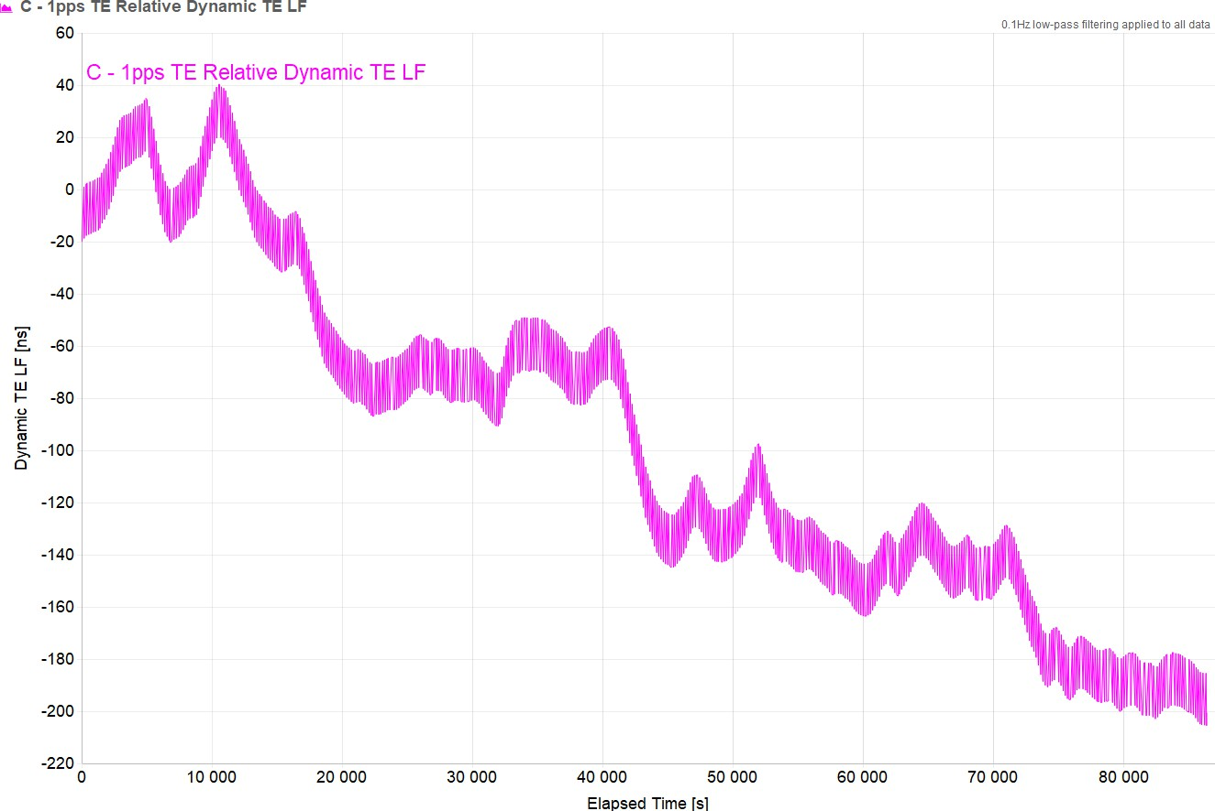

|  |  |
| --- | --- |
| **Mean** | ­100.854 ns |
| **Min** | ­205.545 ns |
| **Max** | 40.328 ns |
| **Max-Min** | 245.873 ns |

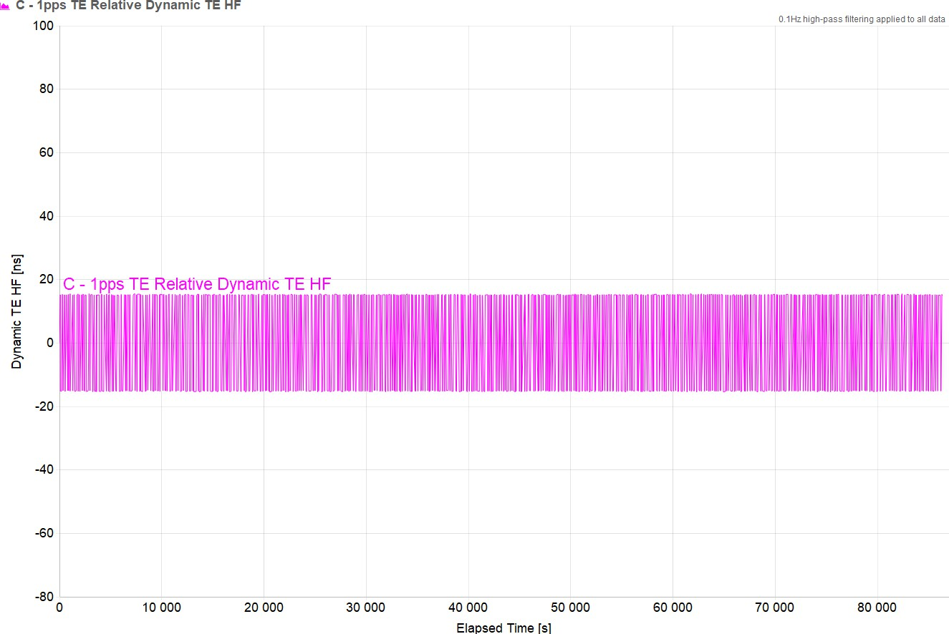

|  |  |
| --- | --- |
| **Mean** | ­0.003 ns |
| **Min** | ­15.468 ns |
| **Max** | 15.568 ns |
| **Max-Min** | 31.036 ns |

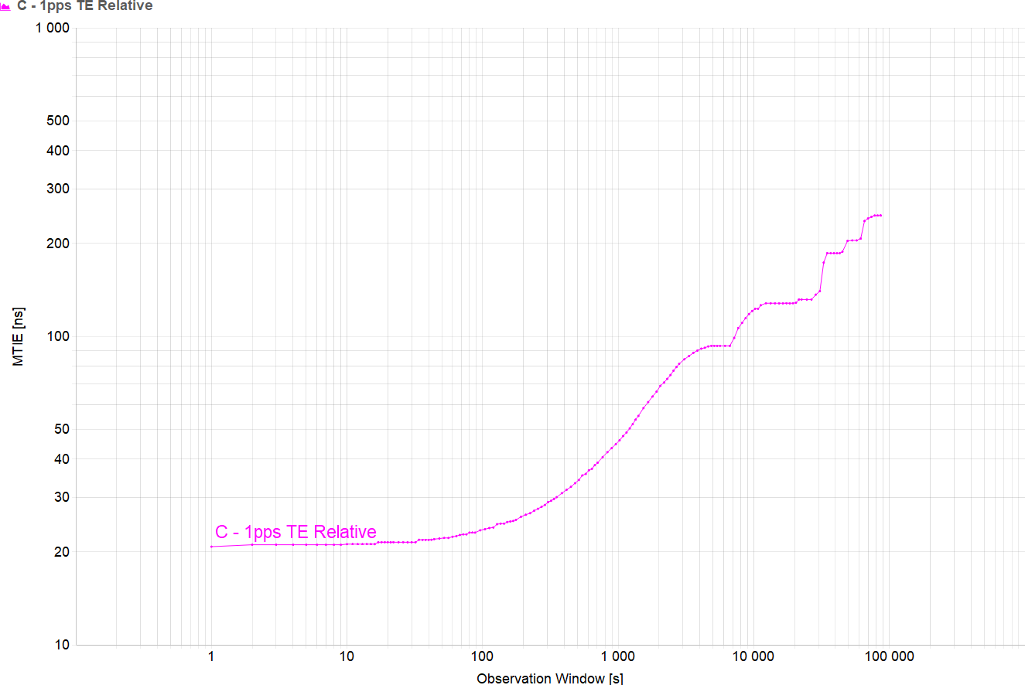

|  |  |
| --- | --- |
| **Min** | 20.8 ns |
| **Max** | 246.4 ns |
| **Max-Min** | 225.6 ns |

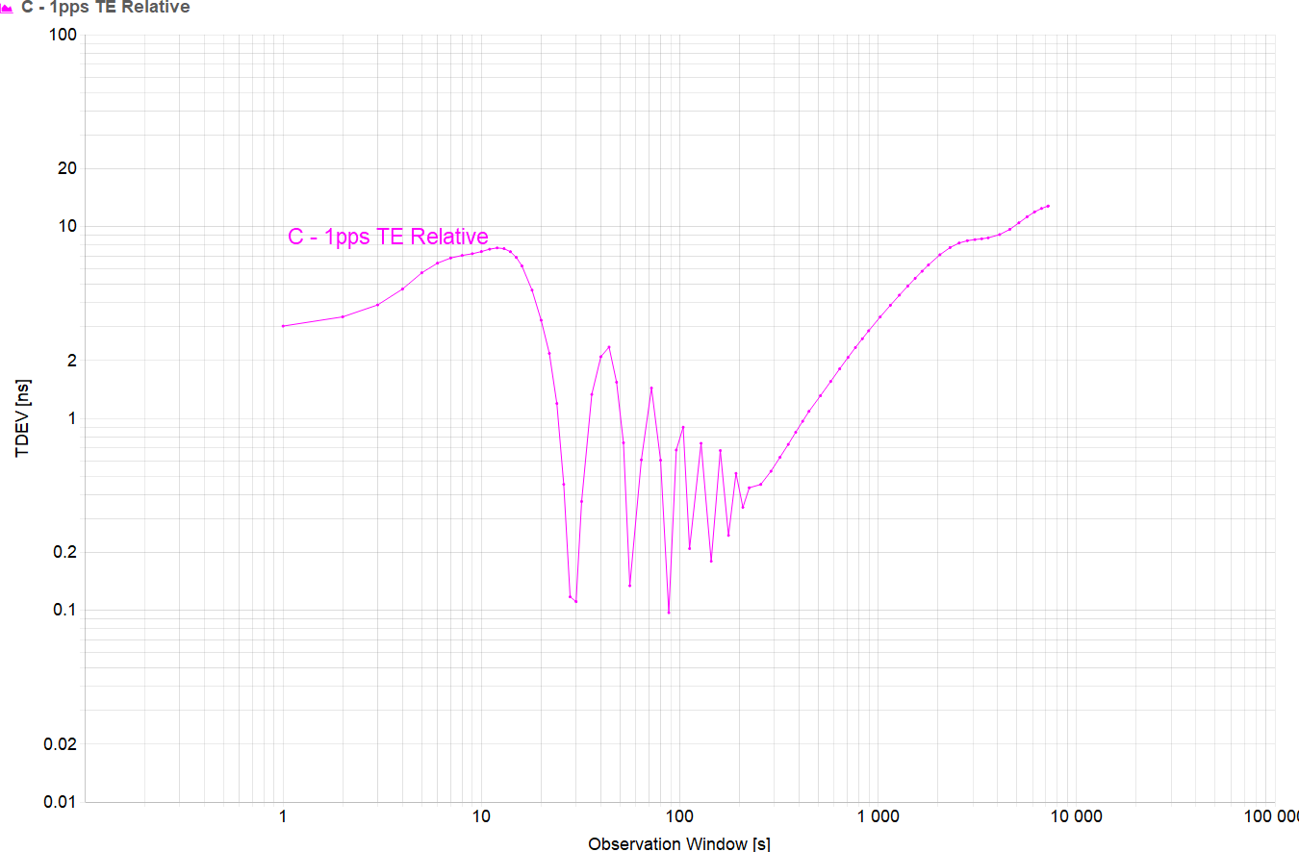

|  |  |
| --- | --- |
| **Min** | 0.097 ns |
| **Max** | 12.781 ns |
| **Max-Min** | 12.684 ns |

|  |  |
| --- | --- |
| **Clock preset (N** | Stratum 2 clock |

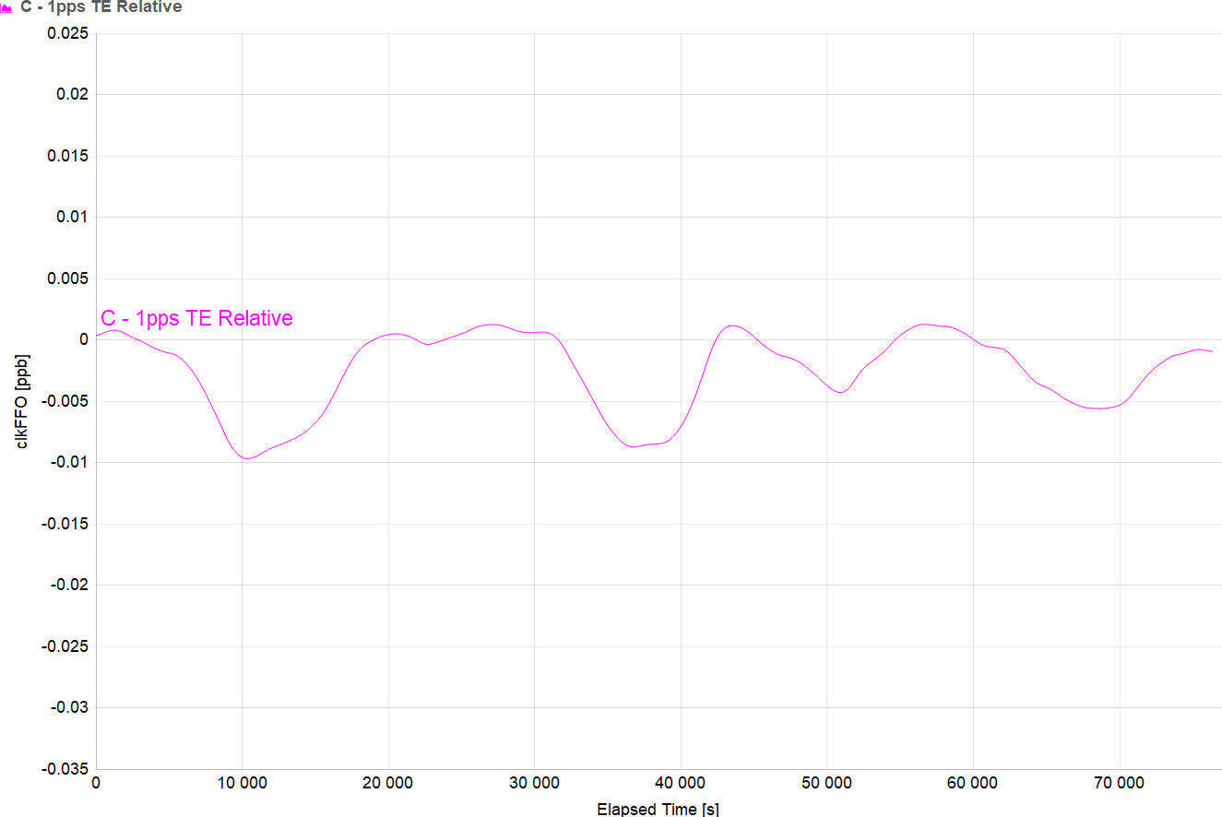

|  |  |
| --- | --- |
| **Mean** | ­0.003 ppb |
| **Min** | ­0.01 ppb |
| **Max** | 0.001 ppb |
| **Max-Min** | 0.011 ppb |

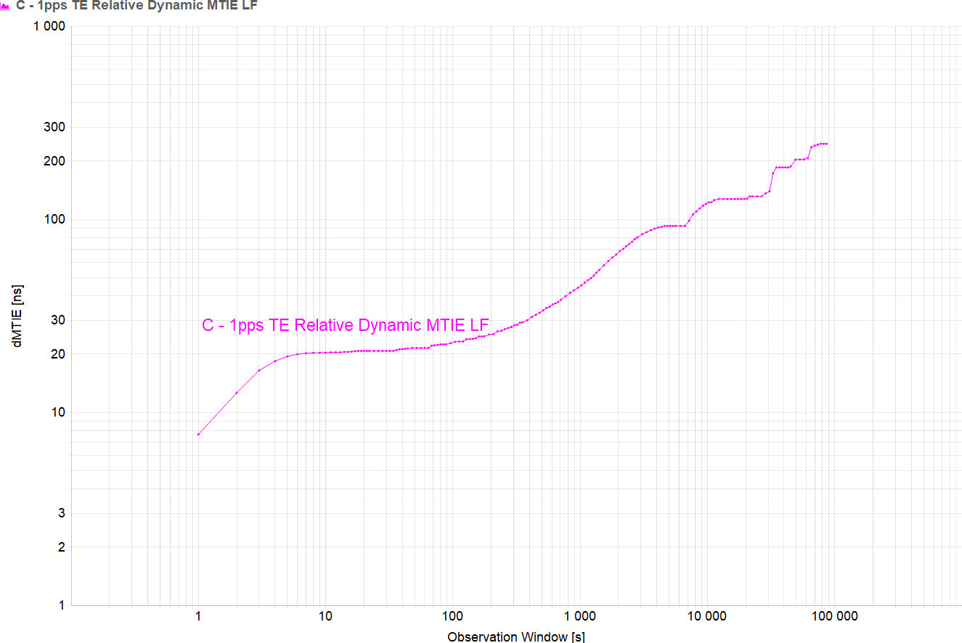

|  |  |
| --- | --- |
| **Min** | 7.673 ns |
| **Max** | 245.873 ns |
| **Max-Min** | 238.2 ns |

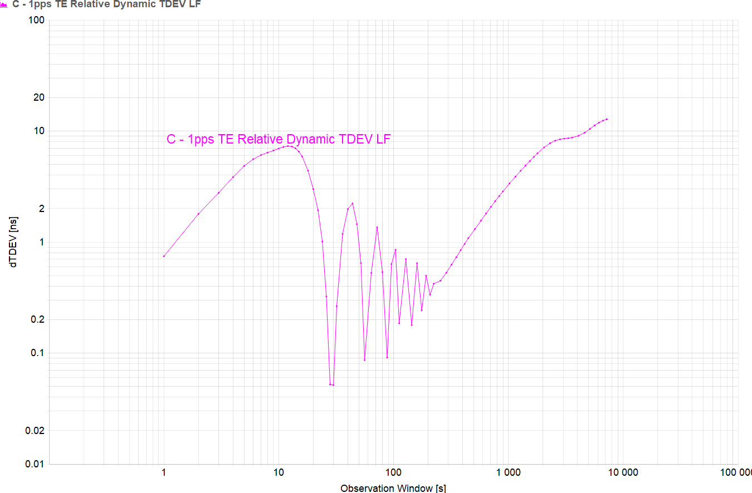

|  |  |
| --- | --- |
| **Min** | 0.051 ns |
| **Max** | 12.779 ns |
| **Max-Min** | 12.727 ns |